Lecture

Sustainability Starts with Support: Protecting Our Workforce Through Change

Ali Heywood, RVN
Principal, Dick White Academy

This lecture examines how true sustainability in the veterinary profession means more than filling roles, it means supporting the people within them across the full arc of their careers. With a predominantly female workforce, it is essential to understand and actively support the unique challenges and transitions many women face. From maternity leave and early years parenting to the impact of menopause, this session will explore how thoughtful policies, flexible working models, and a culture of empathy can protect, retain, and empower professionals at every stage. By addressing these pivotal life phases proactively, we can build a more resilient, inclusive, and future-ready veterinary workforce.
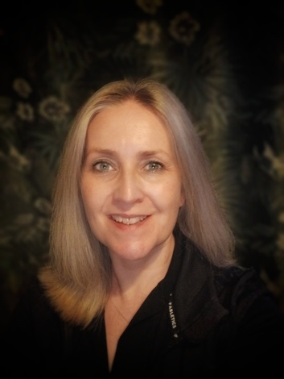

Bio

Ali Heywood, RVN
Principal, Dick White Academy

Ali Heywood is a dedicated veterinary nursing educator and leader with over 25 years of experience in the profession. As Principal of Dick White Academy (DWA), she is committed to developing the next generation of veterinary nurses through high-quality training, coaching, and mentoring. Ali is passionate about creating a supportive learning environment that empowers individuals to grow in confidence, competence, and professionalism.
With a strong background as a Registered Veterinary Nurse (RVN), Ali brings real-world insight to her leadership and teaching. She is particularly focused on championing women in veterinary professions, working to break down barriers and support female colleagues at all stages of their careers. Through her work, she aims to inspire, guide, and advocate for greater equity, visibility, and opportunity for women across the veterinary field.
Before joining DWA, Ali held senior educational roles, including Veterinary Nursing Director and Programme Manager at the College of West Anglia, where she supported the education and development of hundreds of nurses.

