Lecture

How to thrive - building resilience for sustainable futures

Helen Silver-MacMahon

RCVS – Mind matters initiative

In this session we will discover what it means to be human, our innate capabilities and limitations and we will learn to recognize signs of stress in ourselves and others.
We will explore how we can help ourselves, our colleagues and our students manage stressors encountered in everyday work and life.

Bio

Helen Silver-MacMahon

RCVS – Mind matters initiative

Helen qualified as an RVN in 2000 and has worked in both first opinion and referral hospitals. Since qualifying, she has gained certificates in ECC and Small Animal Nutrition and the Advanced Diploma in Veterinary Nursing (surgical).
In 2021, Helen completed a MSc in Patient Safety and Clinical Human Factors at the University of Edinburgh and is currently undertaking a PhD at Sheffield Hallam exploring the non-technical skills that veterinary nurses require when monitoring and maintaining anaesthesia. She is also working towards chartered ergonomist status.

Helen is passionate about developing the veterinary profession's understanding of Human Factors as a powerful aid in improving patient safety, enhancing performance, and supporting the wellbeing of the veterinary team. She enjoys lecturing internationally and has written articles and co-authored several book chapters on both clinical and non-clinical aspects practice. Helen is also collaborating with the University of Aberdeen to research Incivility in veterinary practice.

Lecture

Sustainability Starts with Support: Protecting Our Workforce Through Change

Ali Heywood, RVN
Principal, Dick White Academy

This lecture examines how true sustainability in the veterinary profession means more than filling roles, it means supporting the people within them across the full arc of their careers. With a predominantly female workforce, it is essential to understand and actively support the unique challenges and transitions many women face. From maternity leave and early years parenting to the impact of menopause, this session will explore how thoughtful policies, flexible working models, and a culture of empathy can protect, retain, and empower professionals at every stage. By addressing these pivotal life phases proactively, we can build a more resilient, inclusive, and future-ready veterinary workforce.
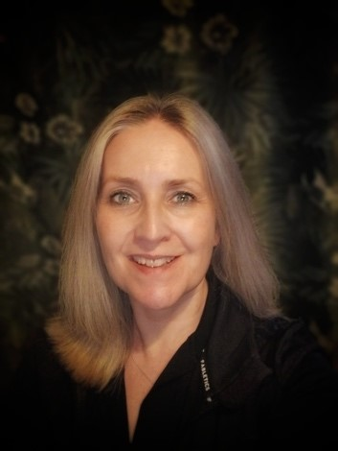

Bio

Ali Heywood, RVN
Principal, Dick White Academy

Ali Heywood is a dedicated veterinary nursing educator and leader with over 25 years of experience in the profession. As Principal of Dick White Academy (DWA), she is committed to developing the next generation of veterinary nurses through high-quality training, coaching, and mentoring. Ali is passionate about creating a supportive learning environment that empowers individuals to grow in confidence, competence, and professionalism.
With a strong background as a Registered Veterinary Nurse (RVN), Ali brings real-world insight to her leadership and teaching. She is particularly focused on championing women in veterinary professions, working to break down barriers and support female colleagues at all stages of their careers. Through her work, she aims to inspire, guide, and advocate for greater equity, visibility, and opportunity for women across the veterinary field.
Before joining DWA, Ali held senior educational roles, including Veterinary Nursing Director and Programme Manager at the College of West Anglia, where she supported the education and development of hundreds of nurses.

Lecture

From Hurt to Heard: Uncovering Misconduct in Veterinary Practice

Saskia Nab

St. Anna-advies

Misconduct, transgressive behavior, and harassment are uncomfortable topics—but they are part of the lived reality for many veterinary professionals. Recent research reveals how frequently such behavior occurs, what forms it takes and who is responsible. The results clearly highlight the disproportionate impact on veterinary nurses. This session explores the prevalence of inappropriate behavior in veterinary clinics and how this could also affect students during internships and in educational settings. It also highlights practical strategies to create safer, more respectful working and learning environments.

Breaking the silence starts here.

Workshop

Speak Up, Stand Strong: Navigating Misconduct in Veterinary Education with the Veterinary DialogueTrainer

Saskia Nab and Quintie Stoel

St. Anna-advies

How do you prepare students to respond to inappropriate behavior from clients, colleagues, or supervisors? In this interactive hands on workshop, you'll experience realistic misconduct scenarios using the Veterinary DialogueTrainer—a digital tool that helps develop communication skills and professional resilience. Together, we’ll explore how to respond effectively to inappropiate behaviour, and how to make such topics discussable in a safe learning environment. This session equips veterinary educators with practical strategies to train students in standing strong and speaking up

Bio

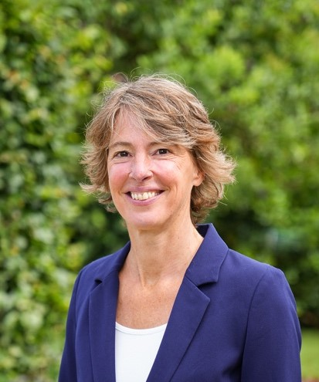
Saskia Nab

St. Anna-advies

rsonal situations. With a strong focus on practical application, Saskia combines her veterinary background with evidence-based training tools—such as the Veterinary DialogueTrainer—to help make difficult topics discussable. Her mission: to create safer, more communicative veterinary workplaces where everyone feels empowered to speak up.

Quintie Stoel

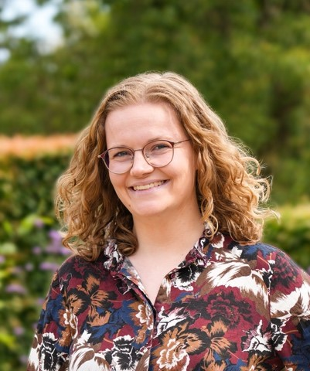
St. Anna-advies

At St. Anna advies, Quintie Stoel is mainly involved in work relating to the Veterinary DialogueTrainer. In 2021, she completed the Master’s degree in Communication Science at Radboud University in Nijmegen. Designing and building conversation simulations and e-learning materials immediately proved to be a perfect combination of her love for writing and interest in communications.

